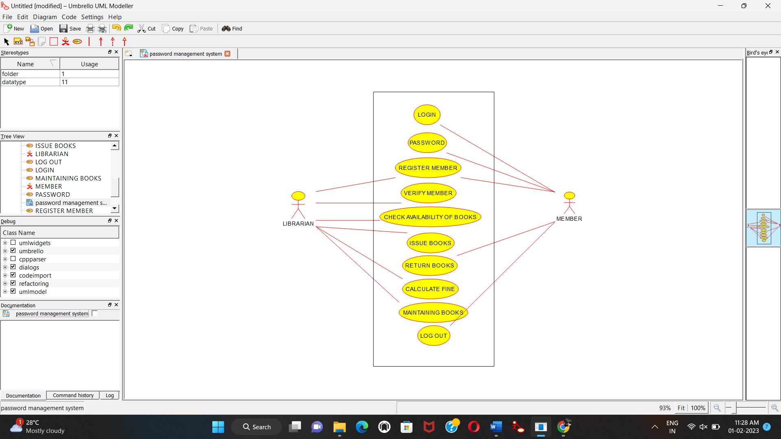

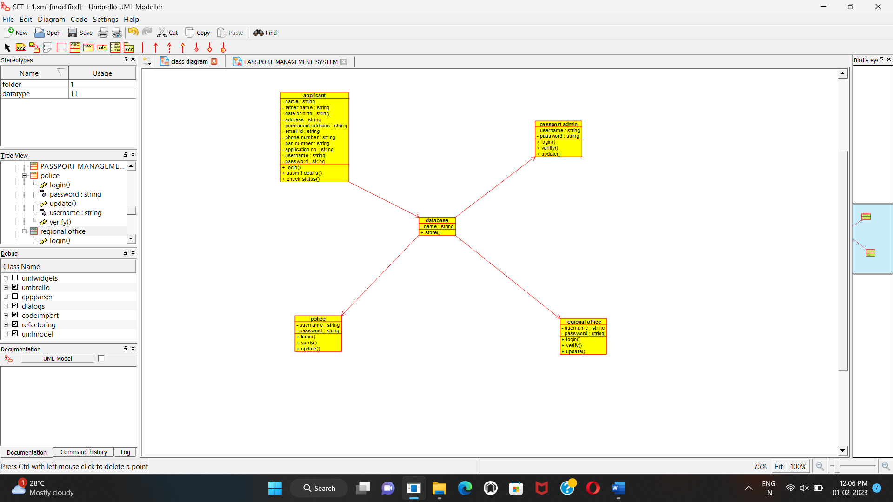

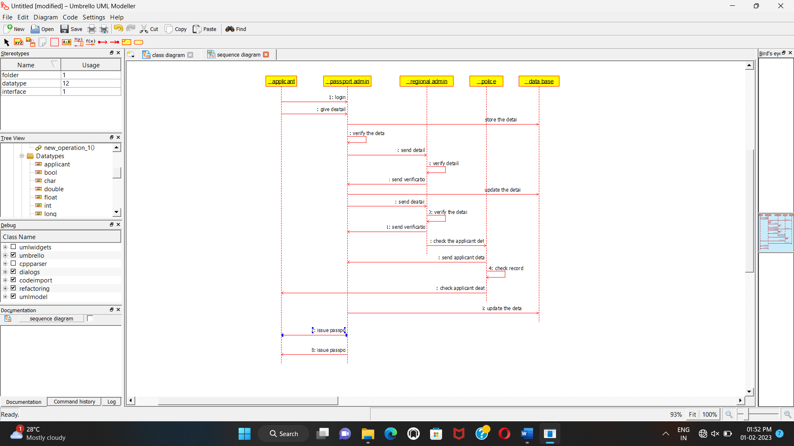

/**

* Class applicant

*/

public class applicant {

//

// Fields

//

private void name;

private String fathername;

private date dob;

private String address;

private void permanent_address;

private void email_id;

private void phoneNum;

private void panNo;

private void applicationNo;

private void username;

private void password;

//

// Constructors

//

public applicant () { };

//

// Methods

//

//

// Accessor methods

//

/**

* Set the value of name

* @param newVar the new value of name

*/

public void setName (void newVar) {

name = newVar;

}

/**

* Get the value of name

* @return the value of name

*/

public void getName () {

return name;

}

/**

* Set the value of fathername

* @param newVar the new value of fathername

*/

public void setFathername (String newVar) {

fathername = newVar;

}

/**

* Get the value of fathername

* @return the value of fathername

*/

public String getFathername () {

return fathername;

}

/**

* Set the value of dob

* @param newVar the new value of dob

*/

public void setDob (date newVar) {

dob = newVar;

}

/**

* Get the value of dob

* @return the value of dob

*/

public date getDob () {

return dob;

}

/**

* Set the value of address

* @param newVar the new value of address

*/

public void setAddress (String newVar) {

address = newVar;

}

/**

* Get the value of address

* @return the value of address

*/

public String getAddress () {

return address;

}

/**

* Set the value of permanent_address

* @param newVar the new value of permanent_address

*/

public void setPermanent_address (void newVar) {

permanent_address = newVar;

}

/**

* Get the value of permanent_address

* @return the value of permanent_address

*/

public void getPermanent_address () {

return permanent_address;

}

/**

* Set the value of email_id

* @param newVar the new value of email_id

*/

public void setEmail_id (void newVar) {

email_id = newVar;

}

/**

* Get the value of email_id

* @return the value of email_id

*/

public void getEmail_id () {

return email_id;

}

/**

* Set the value of phoneNum

* @param newVar the new value of phoneNum

*/

public void setPhoneNum (void newVar) {

phoneNum = newVar;

}

/**

* Get the value of phoneNum

* @return the value of phoneNum

*/

public void getPhoneNum () {

return phoneNum;

}

/**

* Set the value of panNo

* @param newVar the new value of panNo

*/

public void setPanNo (void newVar) {

panNo = newVar;

}

/**

* Get the value of panNo

* @return the value of panNo

*/

public void getPanNo () {

return panNo;

}

/**

* Set the value of applicationNo

* @param newVar the new value of applicationNo

*/

public void setApplicationNo (void newVar) {

applicationNo = newVar;

}

/**

* Get the value of applicationNo

* @return the value of applicationNo

*/

public void getApplicationNo () {

return applicationNo;

}

/**

* Set the value of username

* @param newVar the new value of username

*/

public void setUsername (void newVar) {

username = newVar;

}

/**

* Get the value of username

* @return the value of username

*/

public void getUsername () {

return username;

}

/**

* Set the value of password

* @param newVar the new value of password

*/

public void setPassword (void newVar) {

password = newVar;

}

/**

* Get the value of password

* @return the value of password

*/

public void getPassword () {

return password;

}

//

// Other methods

//

/**

*/

public void login()

{

}

/**

*/

public void submitDetails()

{

}

/**

*/

public void checkstatus()

{

}

}